Practical 7

**Aim: To install SSH (Secure Shell) server on you Ubuntu machine and configure it.**

**Step 1:** It is always necessary to keep your machine up-to-date before you install any type of server or service in it.

sudo apt-get update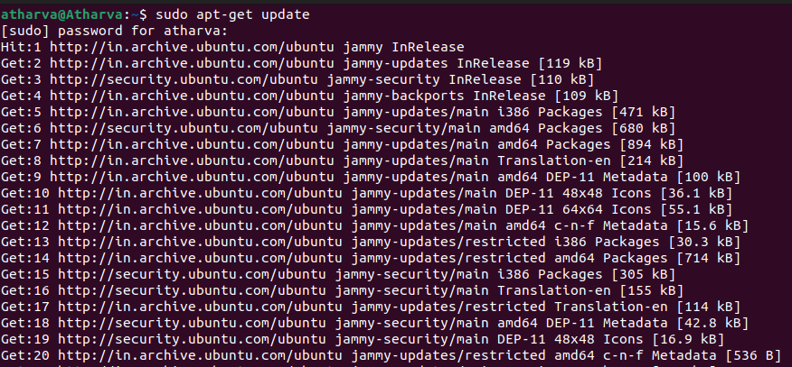

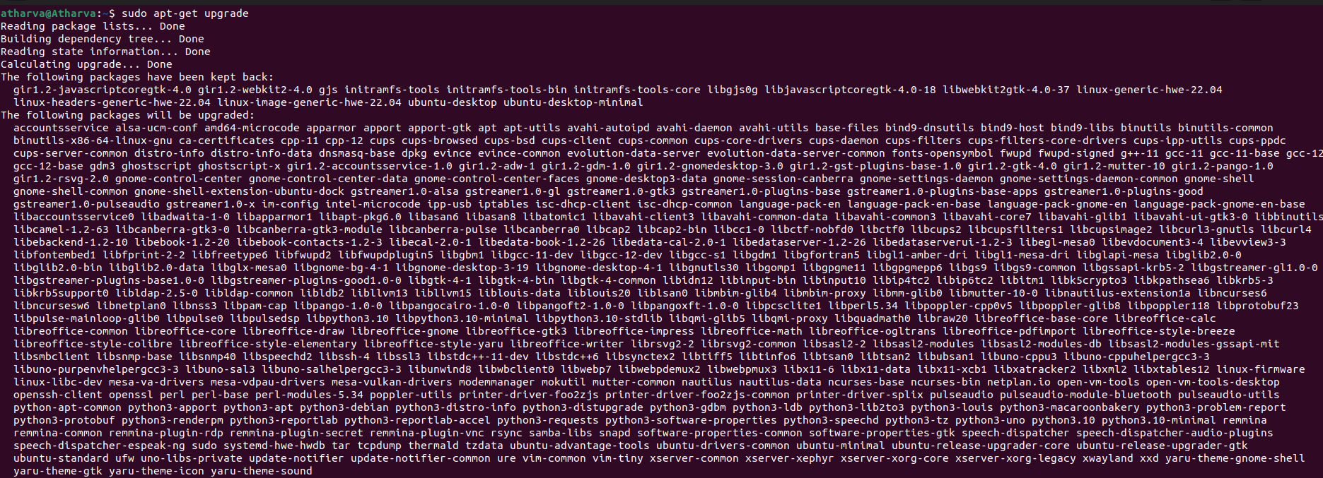sudo apt-get upgrade

**Step 2:** Now we have to install the SSH server, so we use the following command.

sudo apt-get-y install openssh-client

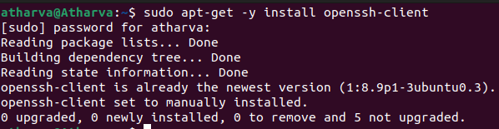

sudo apt-get-y install openssh-server

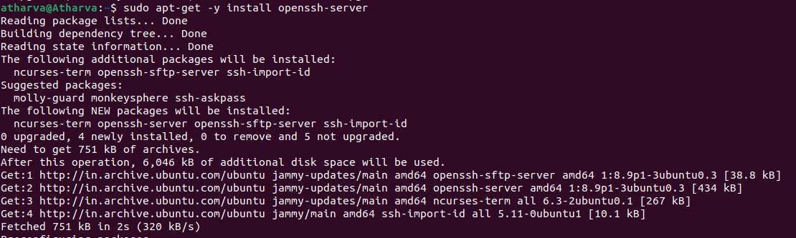

**Step 3:** Now we have to configure the file SSH server which can be done by editing the 'sshd_config' file for that we have to use the following command.

sudo nano /etc/ssh/sshd_config

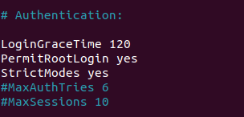

**Step 4:** Now we have to restart the ssh server which can be done by following command.

sudo systemctl restart ssh



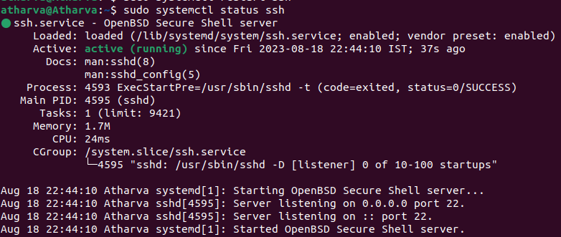

**Step 5:** After installing all the necessary servers on your ubuntu machine install Putty on your Windows client and open it put your ubuntu machine's ip address which can be known by using ifconifg command.

